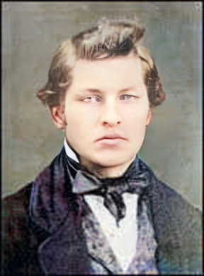
John Sample Doe
Born 26 SEP 1875 • Ceska Trebova, Okres Ústí nad Orlicí, Pardubický (Pardubice), Czech Republic
Died 24 Oct 1941 • Cedar Rapids, Linn County, Iowa, United States
Buried at Czech National Cemetery – Cedar Rapids, Linn County, Iowa, United States
Relationship to me : adoptive great-grandfather

- Son of Antonin Doe and Marie Smith
- Brother to Marie Doe
- Husband to Marie Antoinette Jones
- Father to Frank Doe, John Edward Doe, Rosemary Doe, Robert Thomas Doe

Biography

Sources
Template provided by FilipGenealogy

